**AWS CloudFormation**

* **Go to aws cloud console**
* **Click Create Stack**

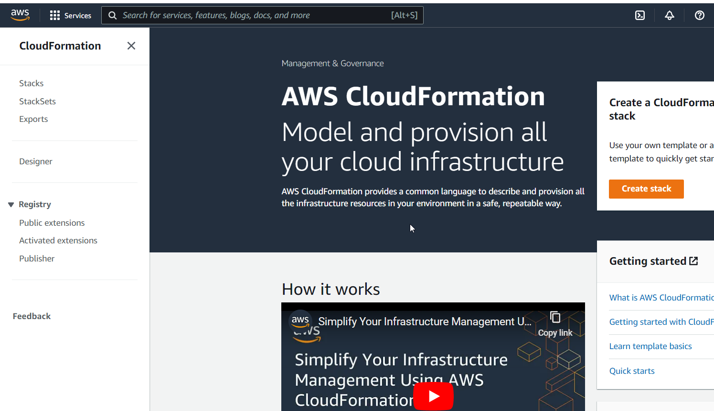

0-just-ec2.yaml

(Your ec2 instance should be same as current working region)

---

Resources:

  MyInstance:

    Type: AWS::EC2::Instance

    Properties:

      AvailabilityZone: us-east-1a

      ImageId: ami-a4c7edb2

      InstanceType: t2.micro

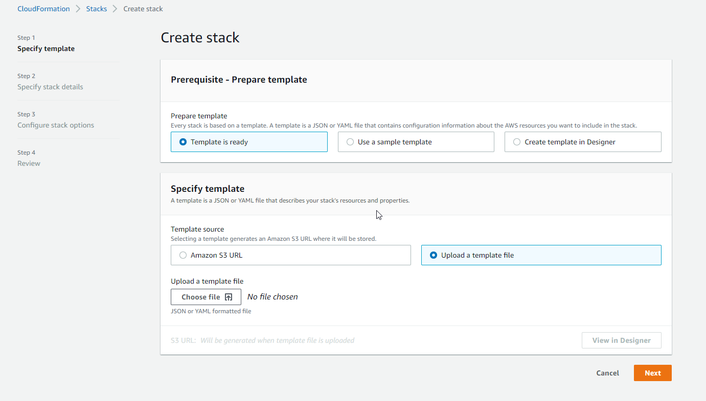

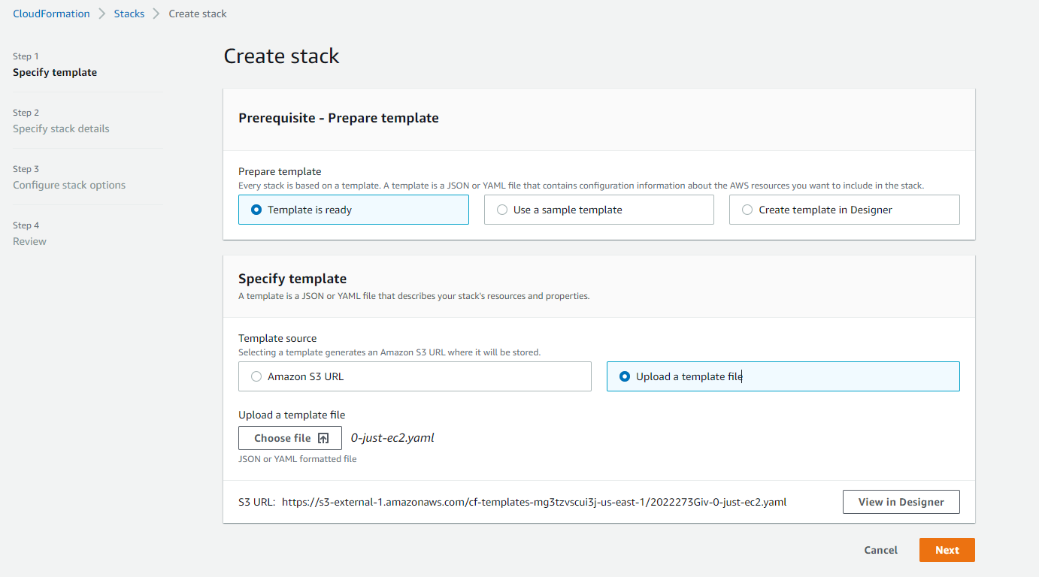

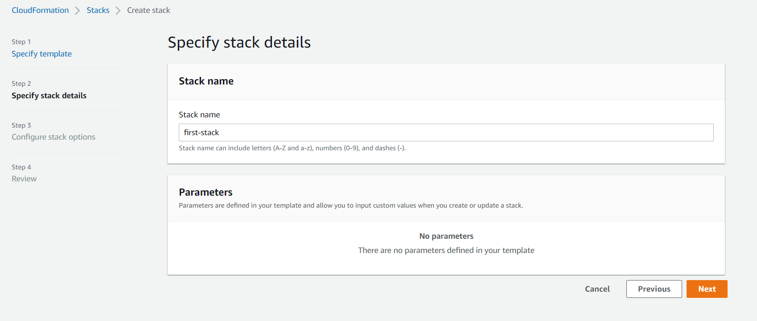

Configure stack options keep default

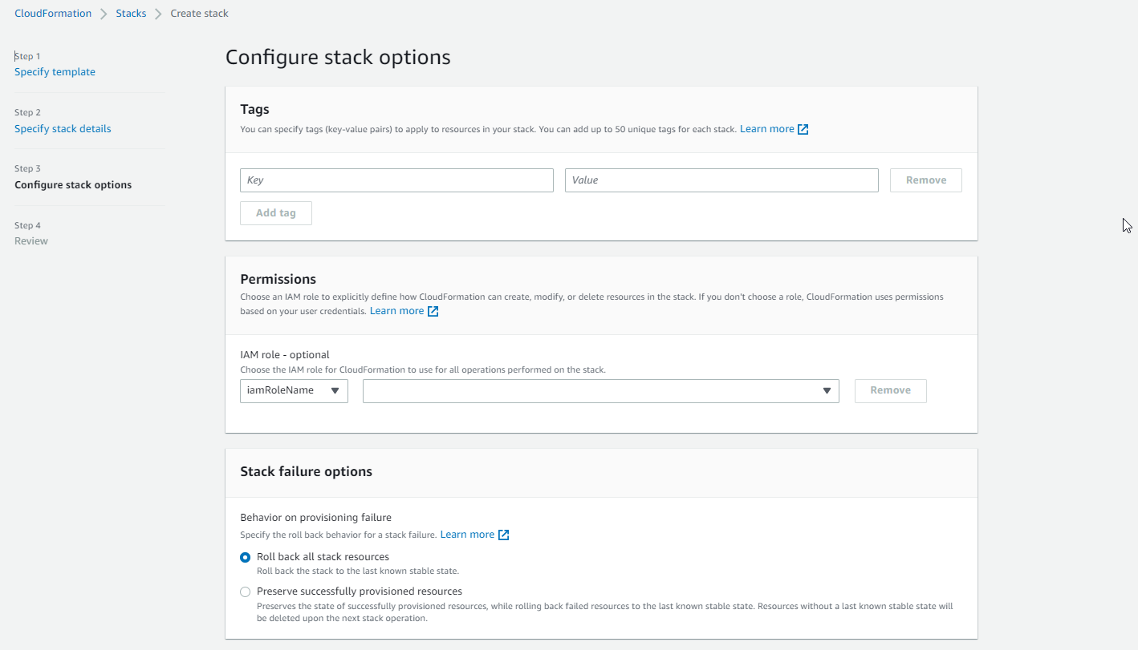

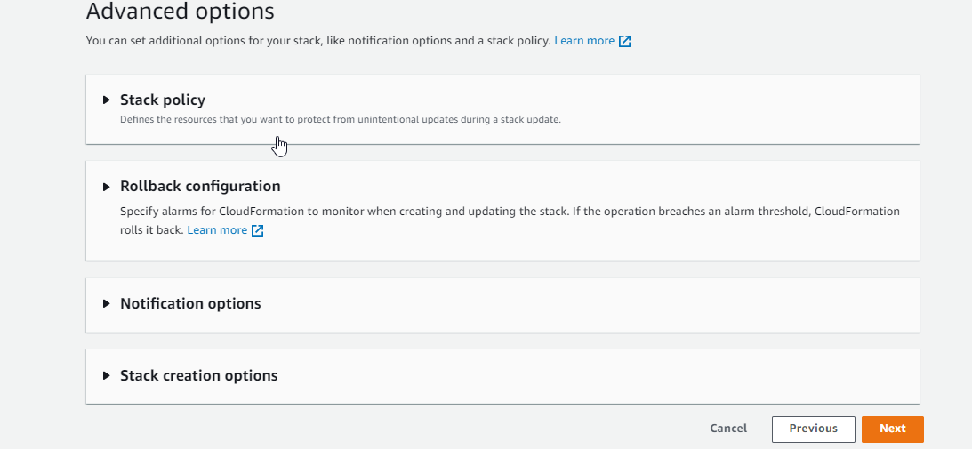

Once Review

Click Create Stack

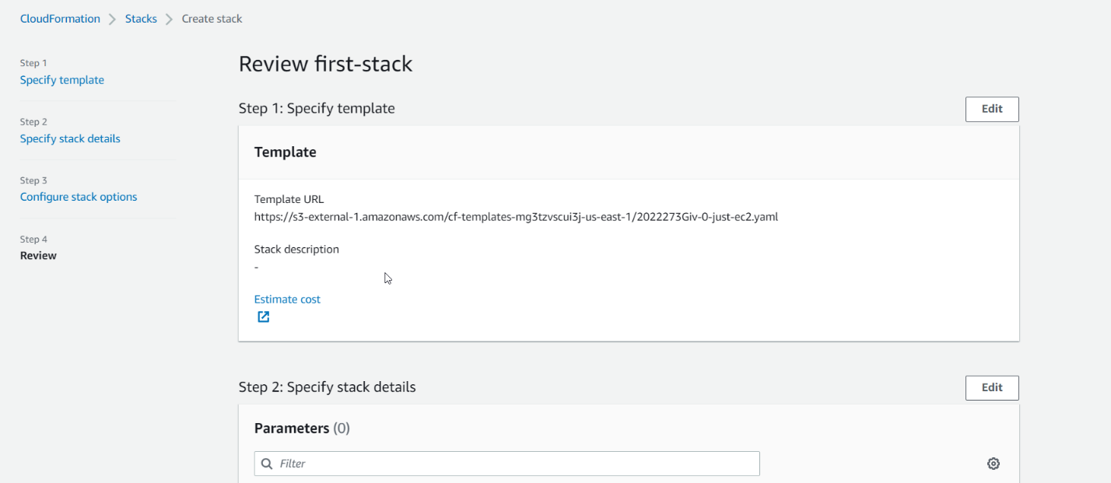

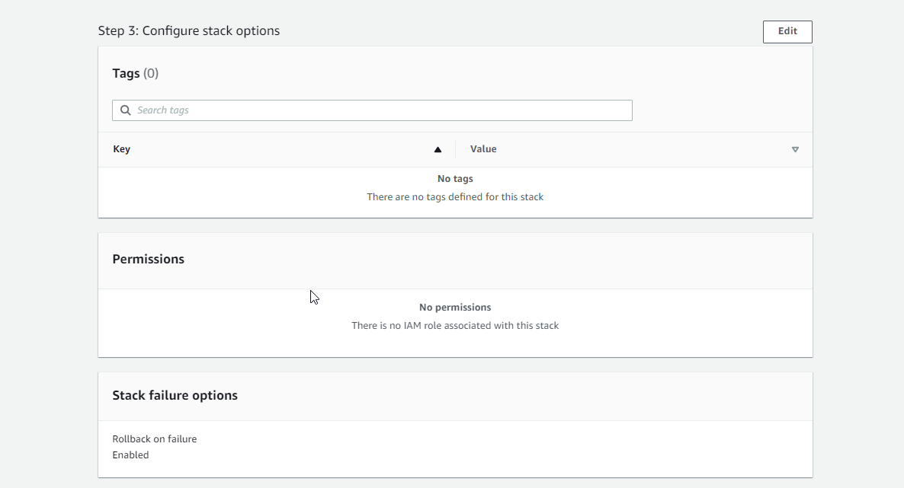

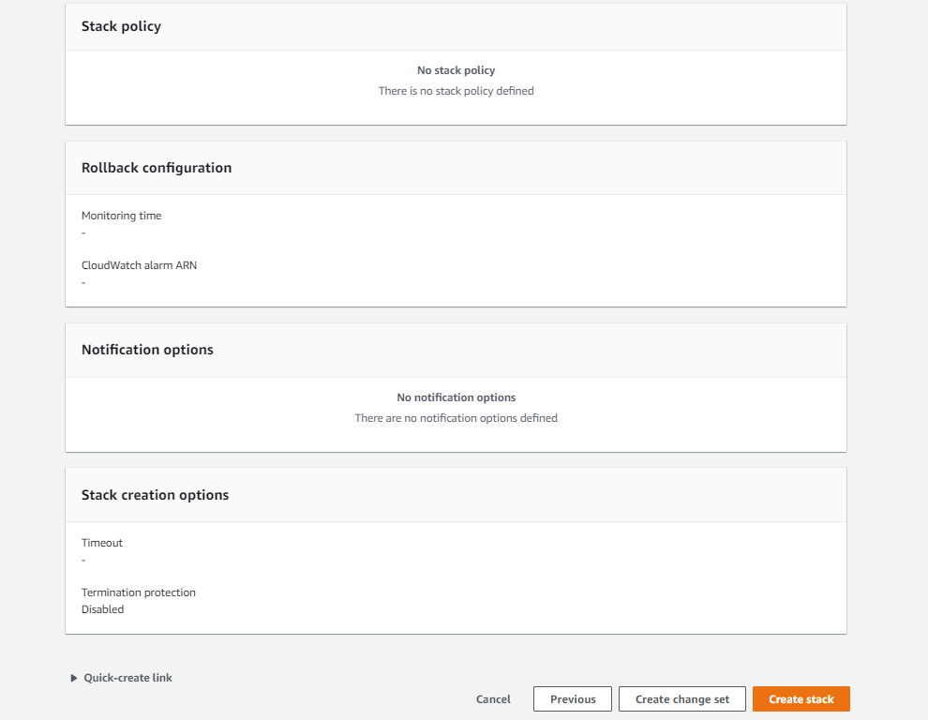

You will see my cloud formation has successfully created ec2 instance.

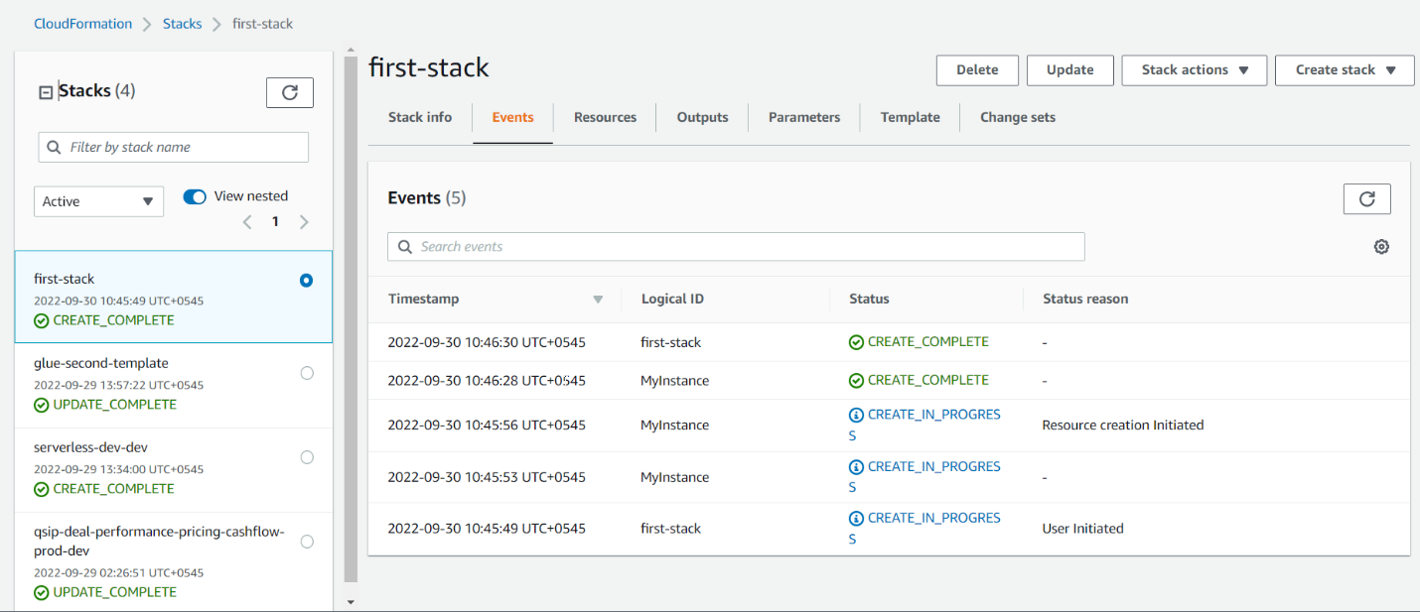

Go to EC2 INSTANCE, YOU WILL SEE YOUR EC2 INSTANCE BEING CREATED.

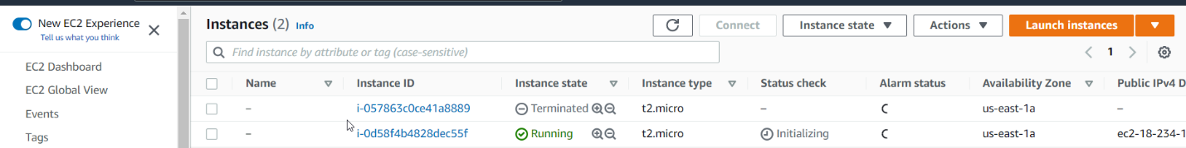

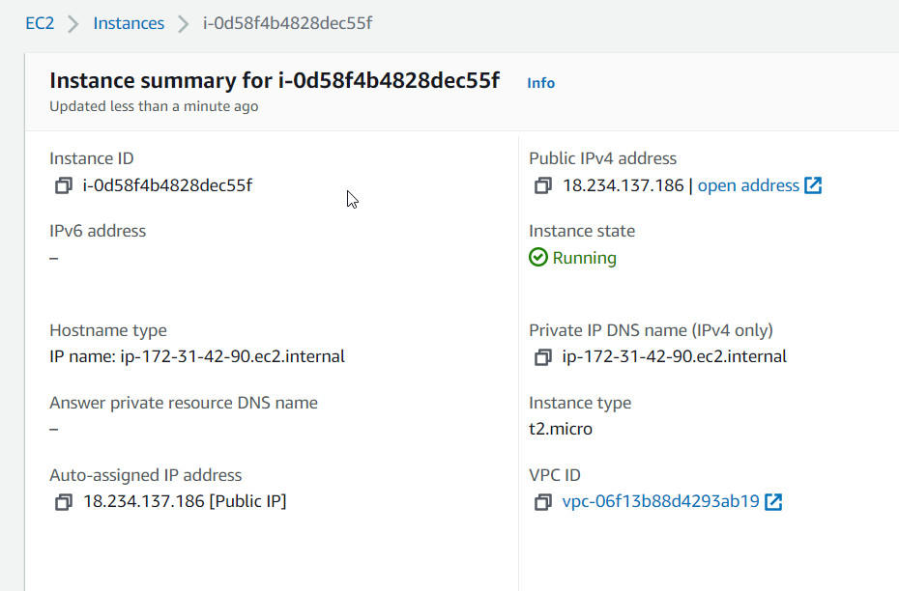

WE CAN SEE RESOURCE RUNNING

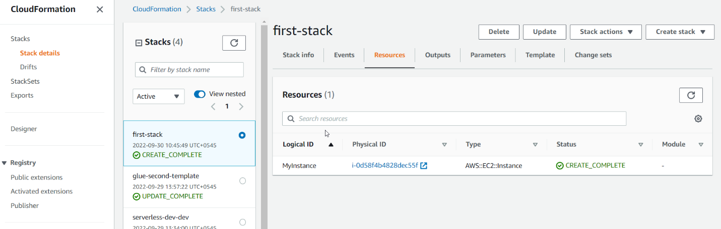

TEMPLATE

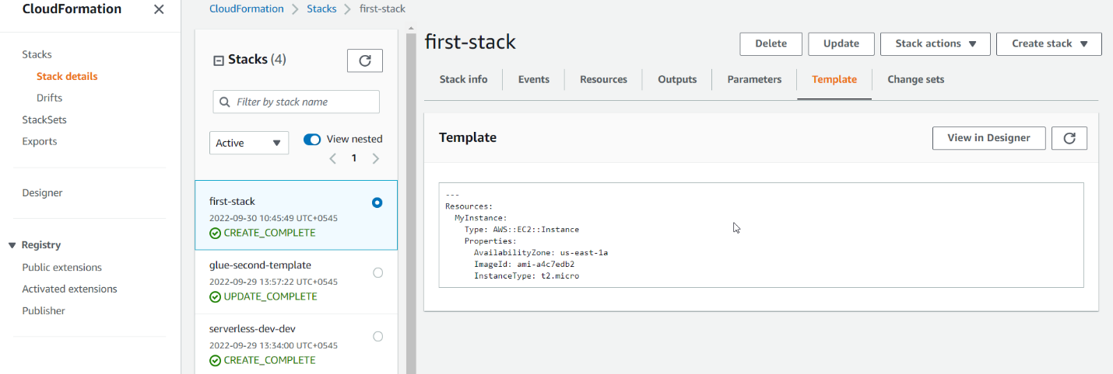

Go to View in Designer

We can see your instance being created.

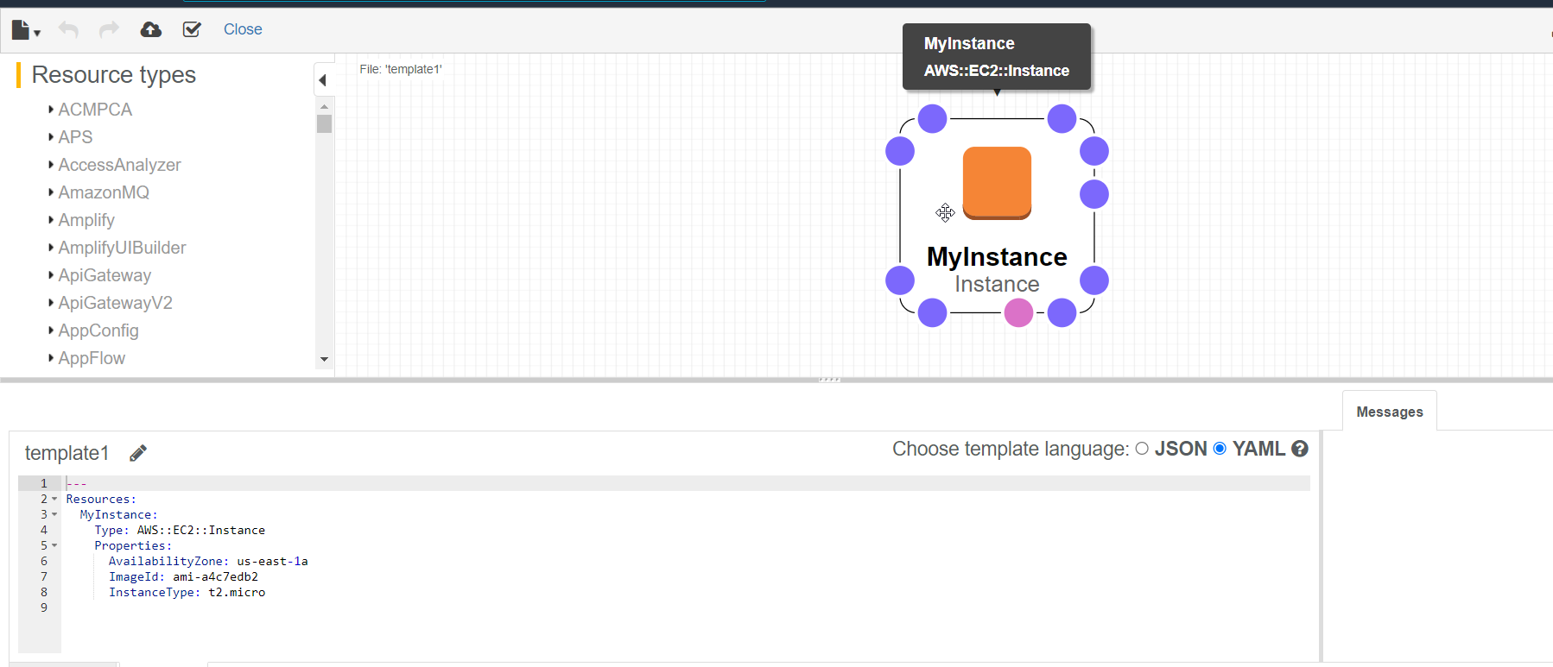

Update CloudFormation

Select your CloudFormation and Click Update

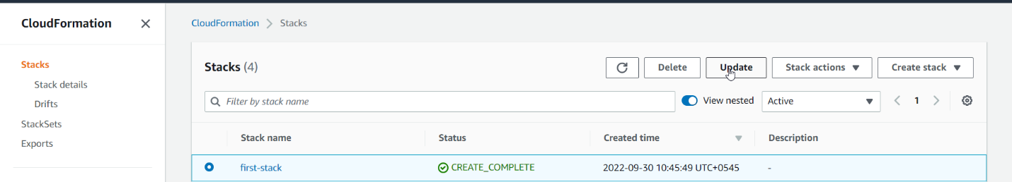

Choose Replace current template

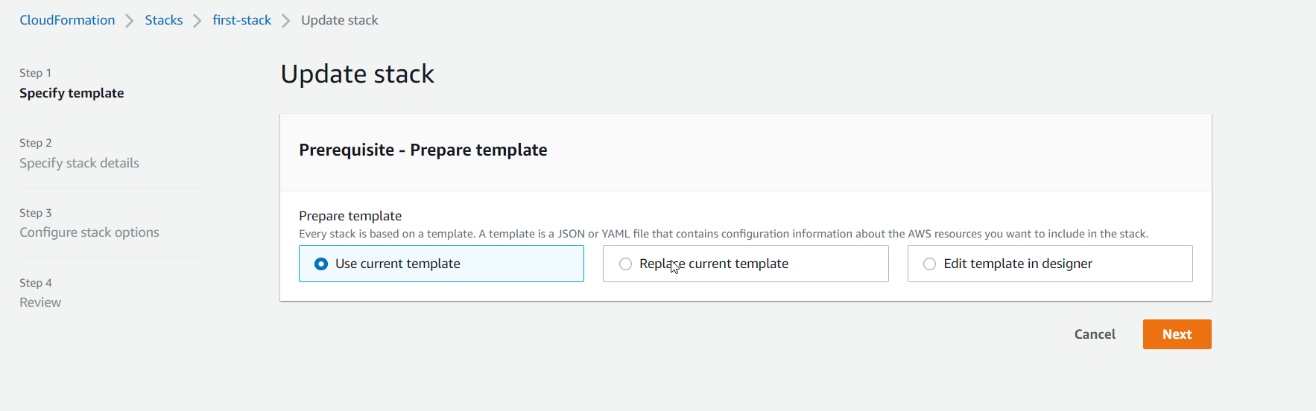

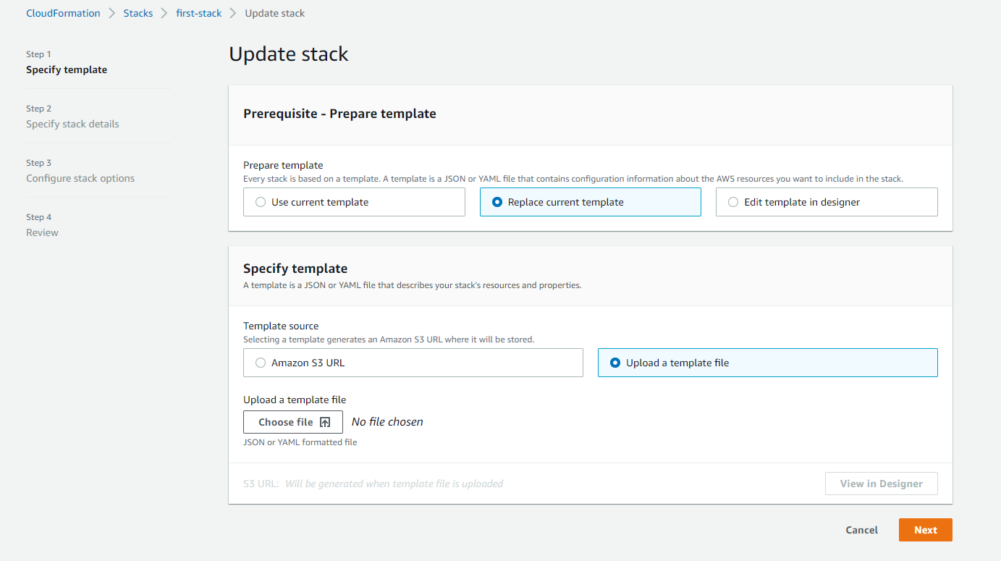

* Select Upload a template file
* Click Choose file.
* Click Next.

1-ec2-with-sg-eip.yaml

---

Parameters:

  SecurityGroupDescription:

    Description: Security Group Description

    Type: String

Resources:

  MyInstance:

    Type: AWS::EC2::Instance

    Properties:

      AvailabilityZone: us-east-1a

      ImageId: ami-a4c7edb2

      InstanceType: t2.micro

      SecurityGroups:

        - !Ref SSHSecurityGroup

        - !Ref ServerSecurityGroup

  # an elastic IP for our instance

  MyEIP:

    Type: AWS::EC2::EIP

    Properties:

      InstanceId: !Ref MyInstance

  # our EC2 security group

  SSHSecurityGroup:

    Type: AWS::EC2::SecurityGroup

    Properties:

      GroupDescription: Enable SSH access via port 22

      SecurityGroupIngress:

      - CidrIp: 0.0.0.0/0

        FromPort: 22

        IpProtocol: tcp

        ToPort: 22

  # our second EC2 security group

  ServerSecurityGroup:

    Type: AWS::EC2::SecurityGroup

    Properties:

      GroupDescription: !Ref SecurityGroupDescription

      SecurityGroupIngress:

      - IpProtocol: tcp

        FromPort: 80

        ToPort: 80

        CidrIp: 0.0.0.0/0

      - IpProtocol: tcp

        FromPort: 22

        ToPort: 22

        CidrIp: 192.168.1.1/32

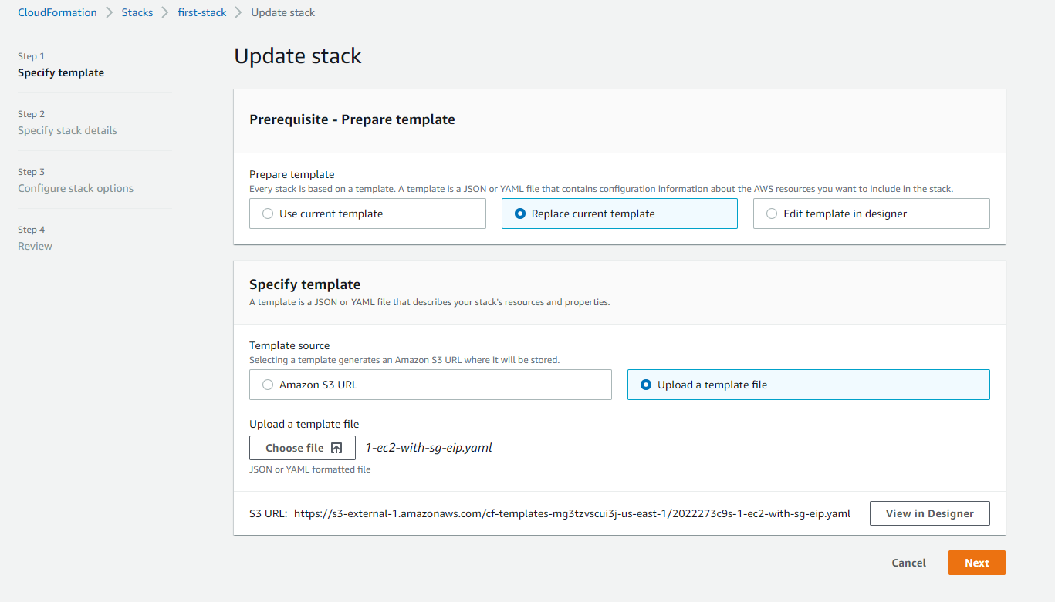

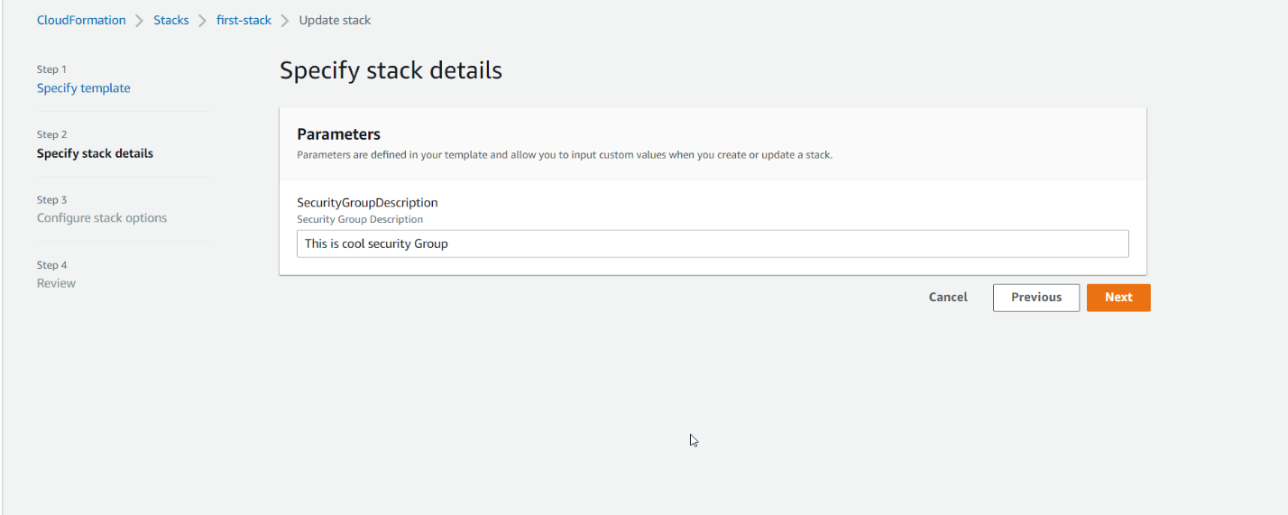

Keep default configure stack options

Click Next.

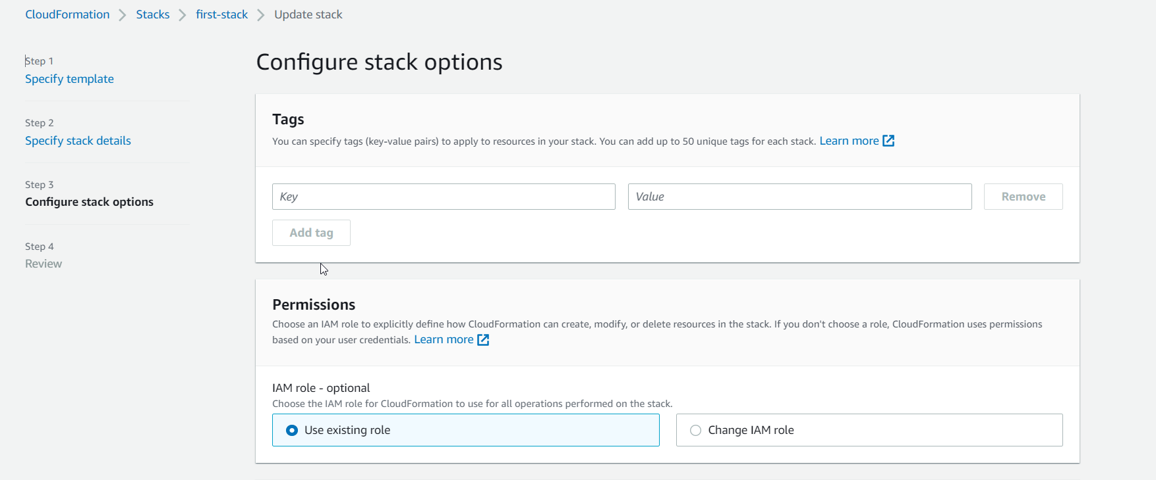

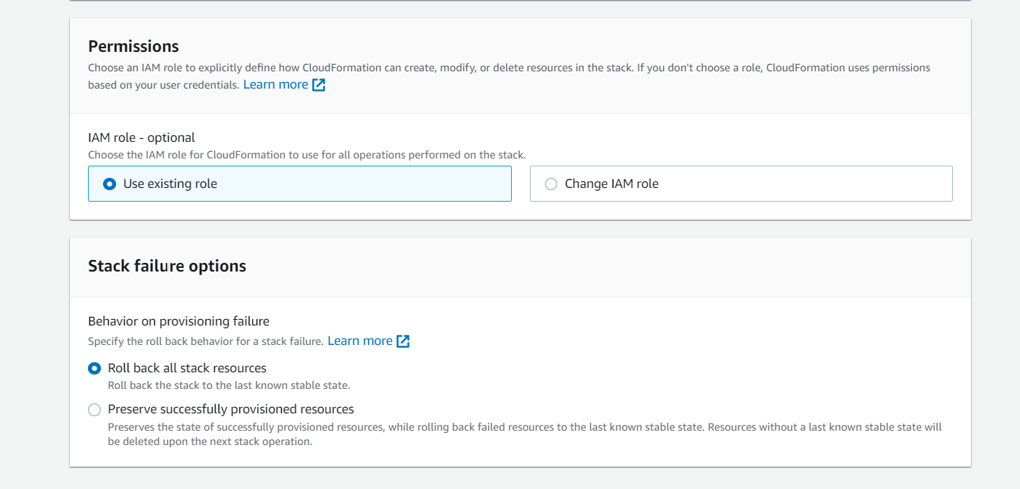

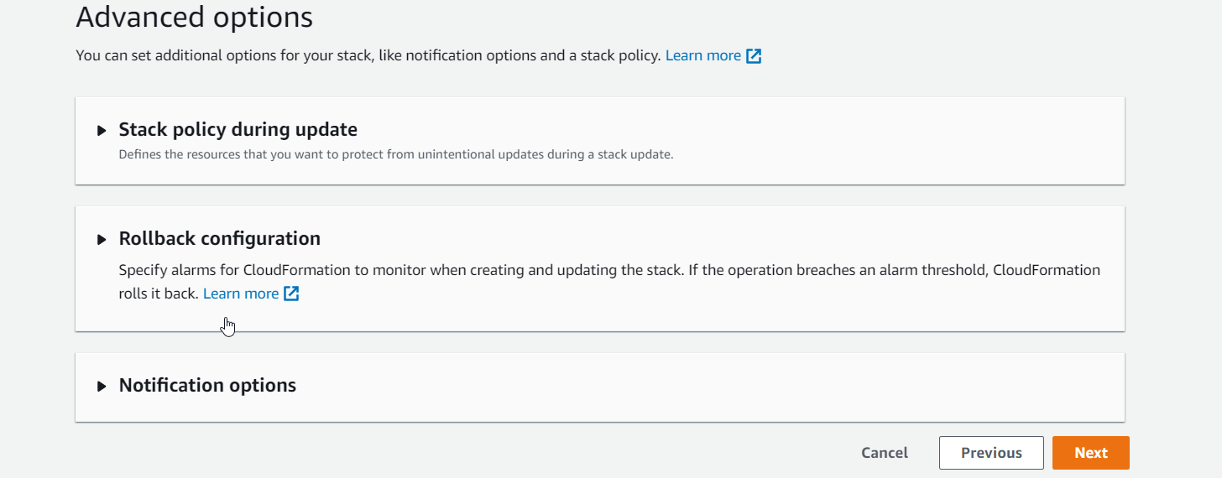

At the button of Review page, we cab see Change set Preview.

Click update stack

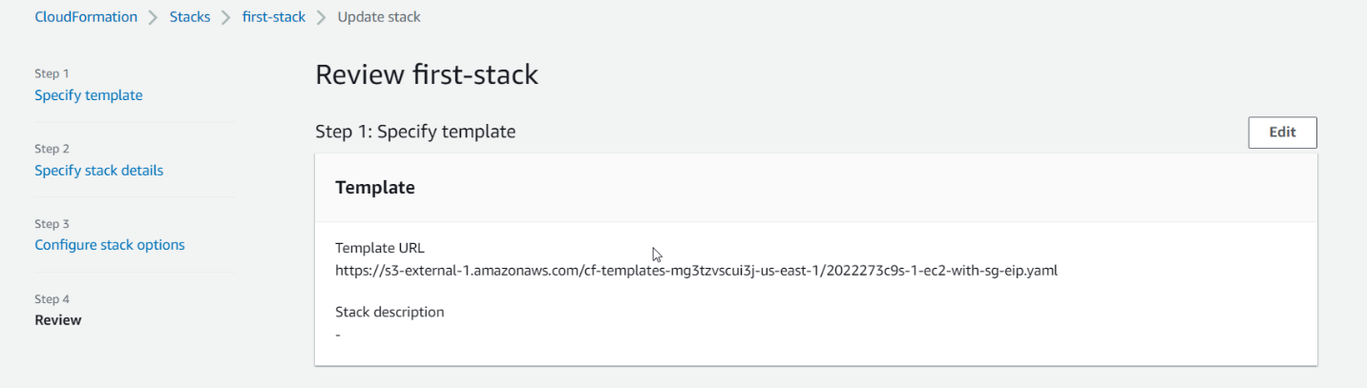

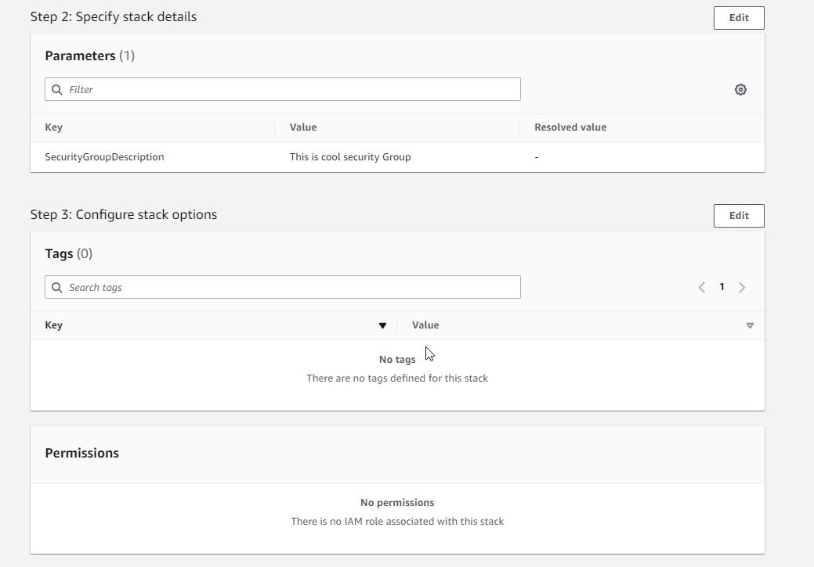

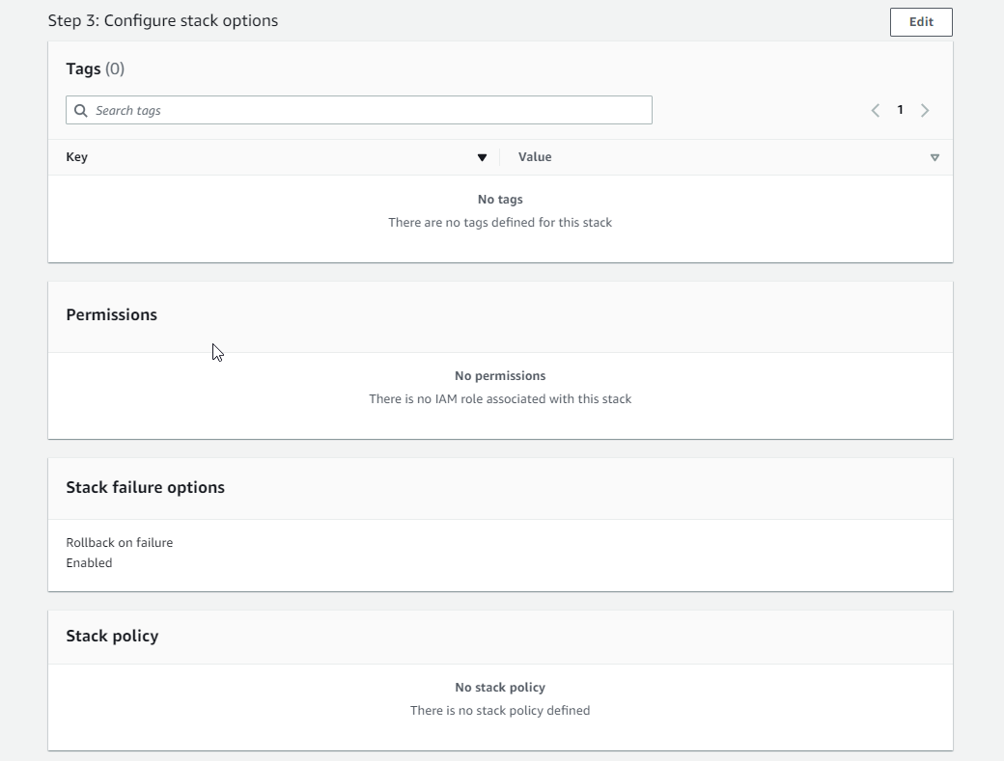

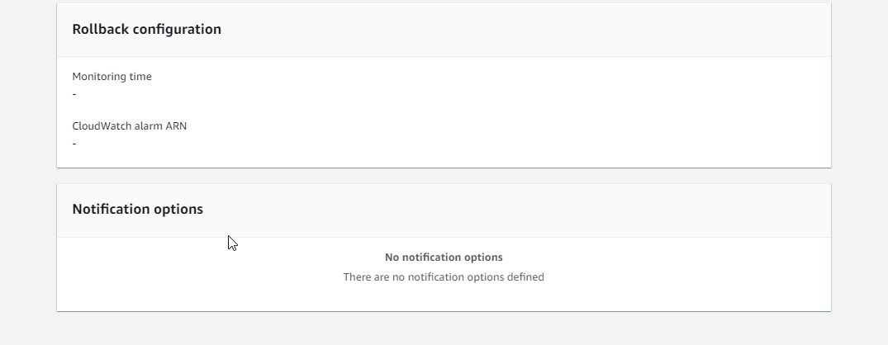

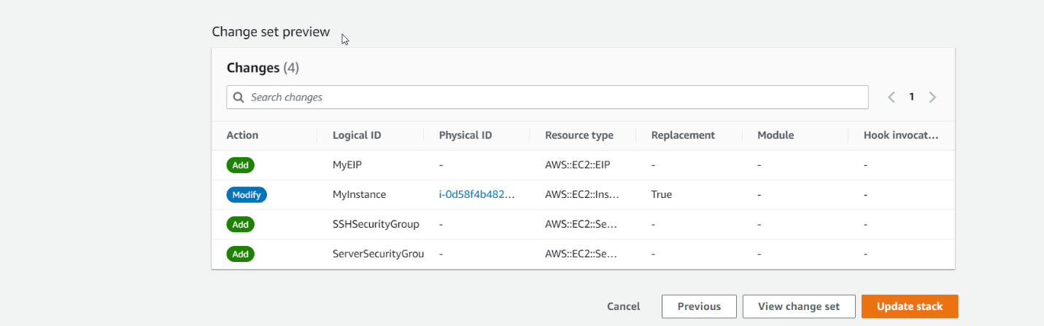

Now you can see new updates on your stack.

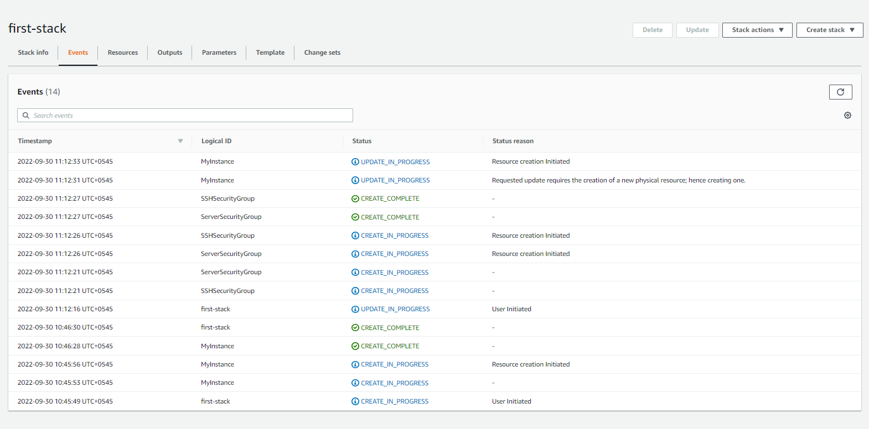

Our first instance is deleted.

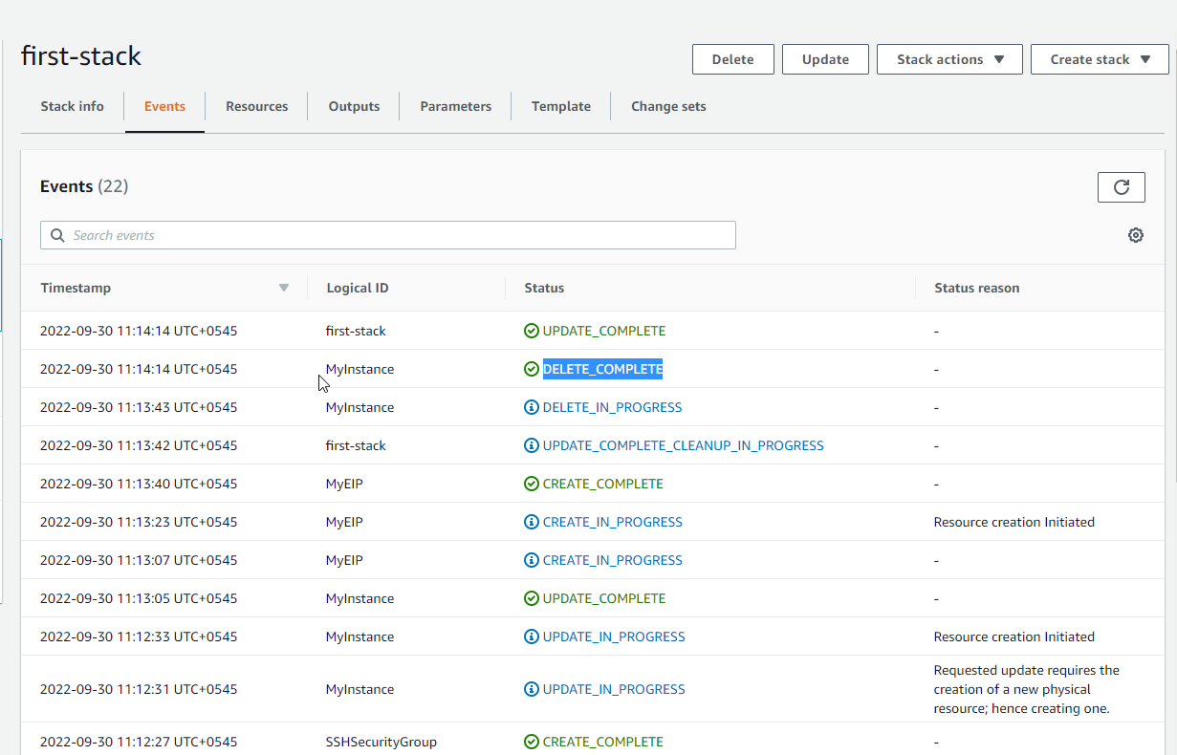

Go to ec2 instance you will see change.

New instance created

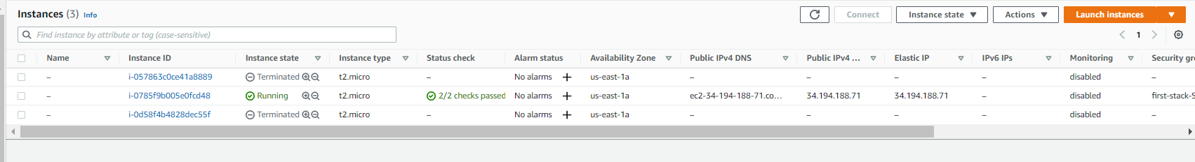

Go to RESOURCES and select MY

EC2 INSTANCE

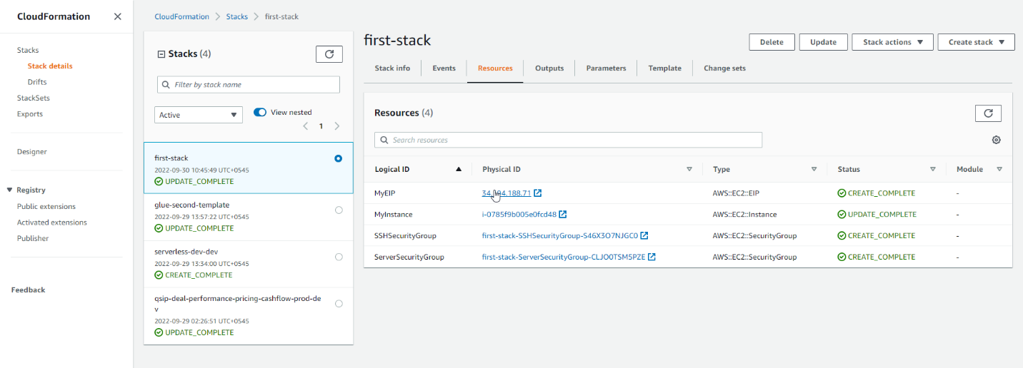

SELECT ELASTIC IP ADDRESS

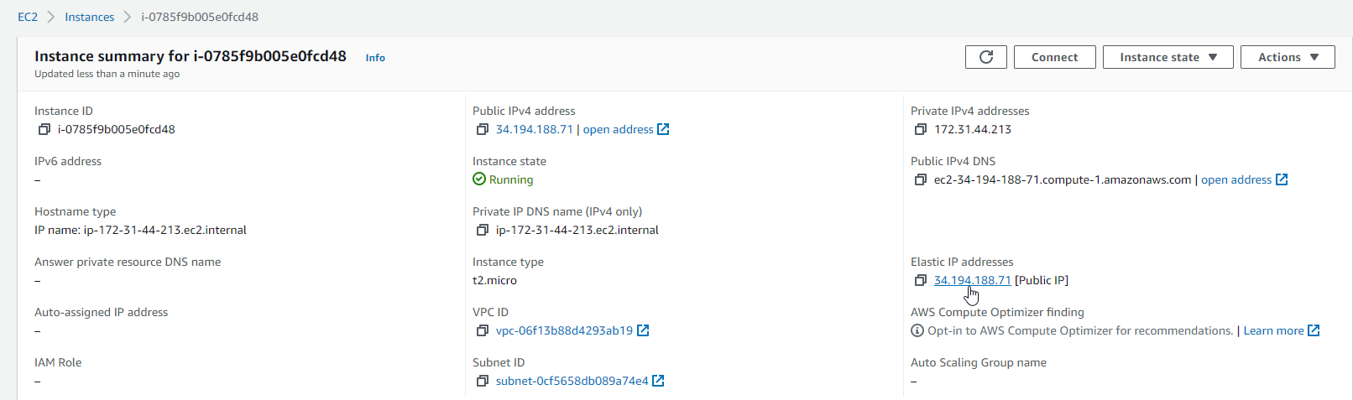

IT HAS BEEN TAG

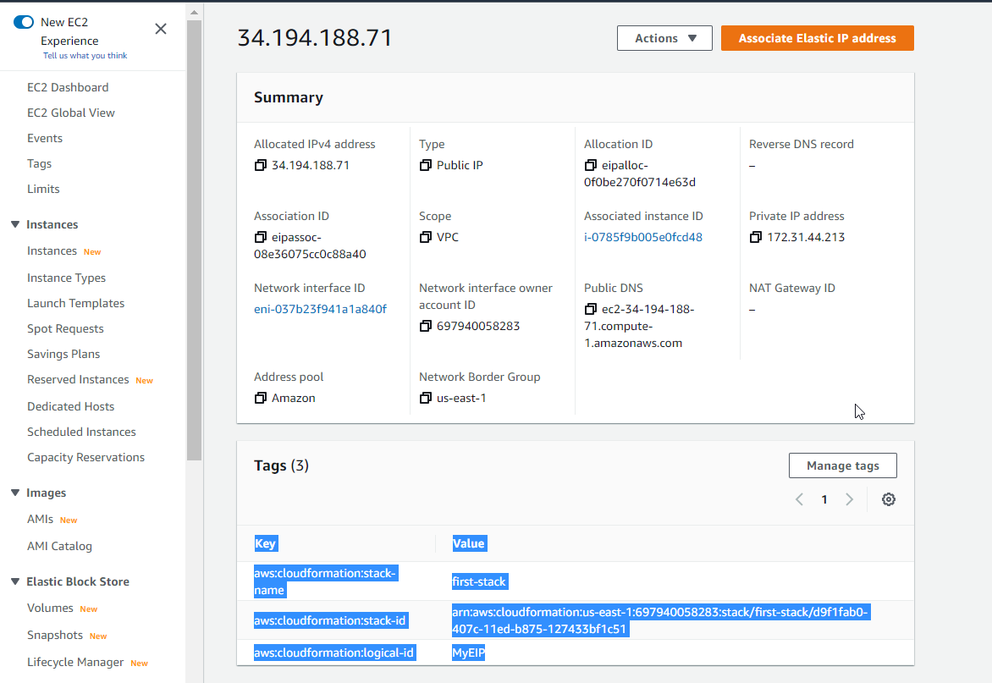

Go to security Group, we have two security group

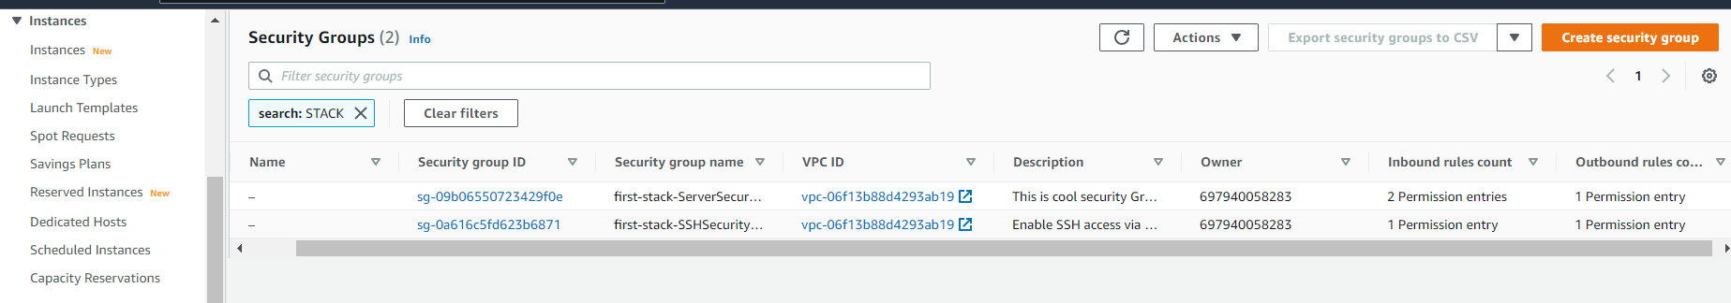

We have SSH INBOUN RULE.

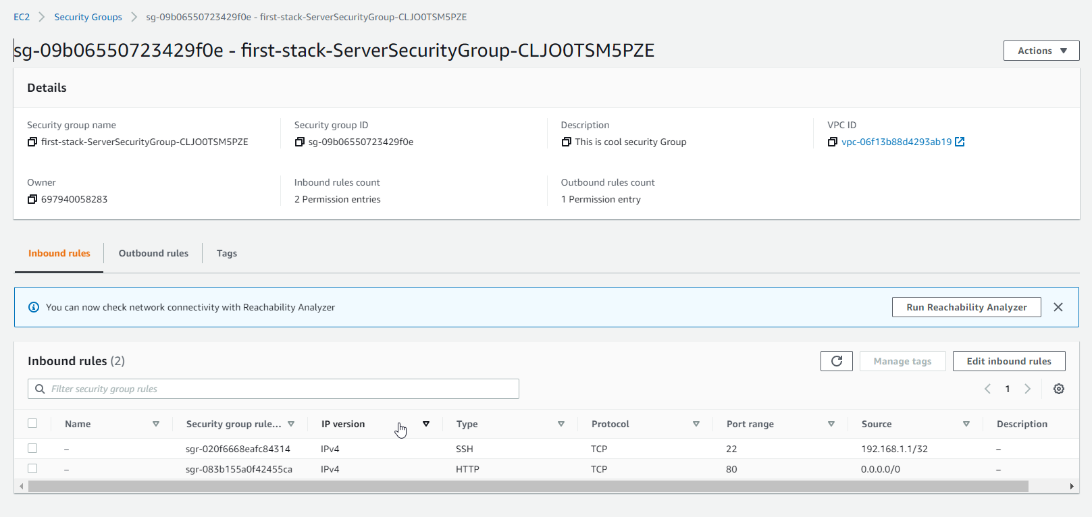

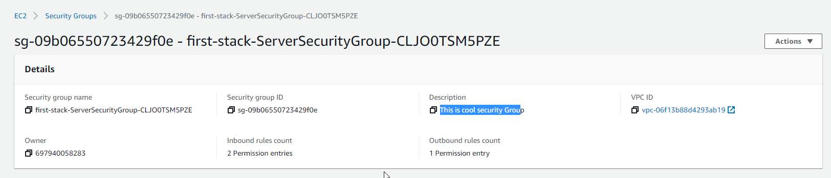

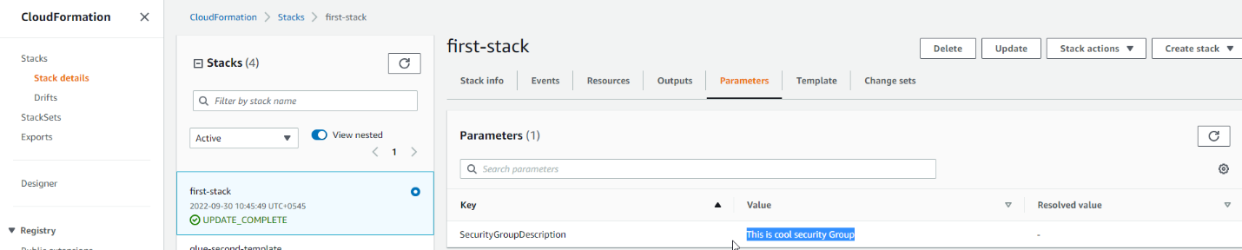

THE BEST WAY TO DELETE EVRYTHING IS DELETE STACK

CLICK DELETE

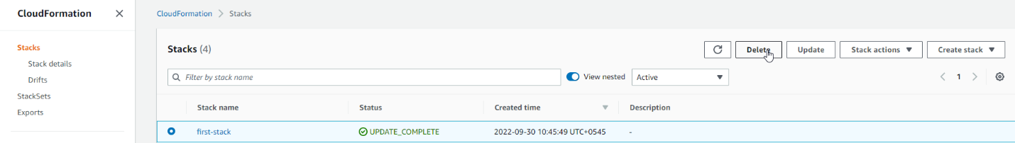

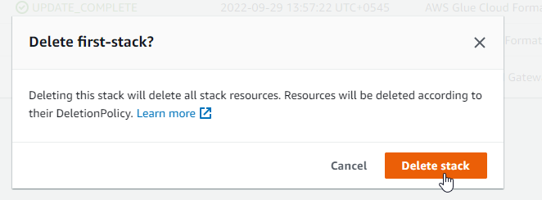

YOU WILL SEE IT DELETE EVERYTHING ONE BY ONE.

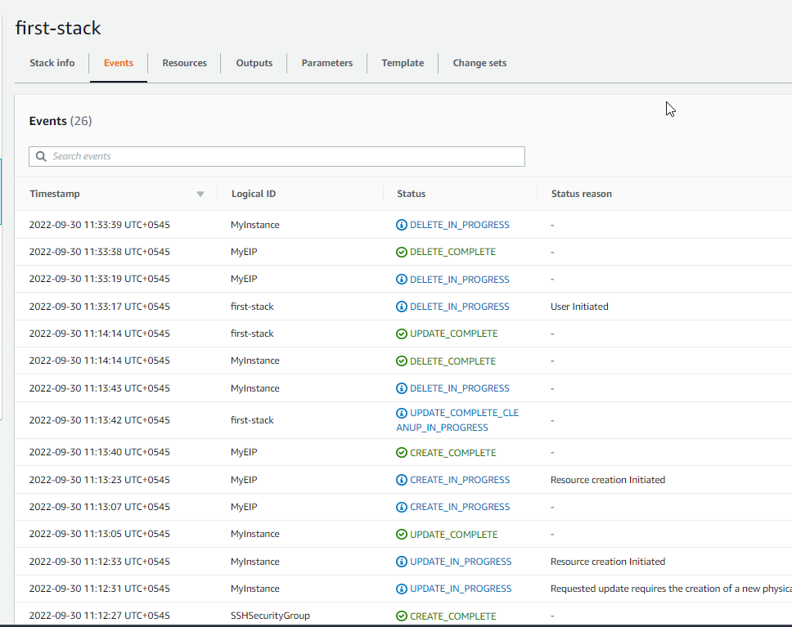

**CloudFormation drift**

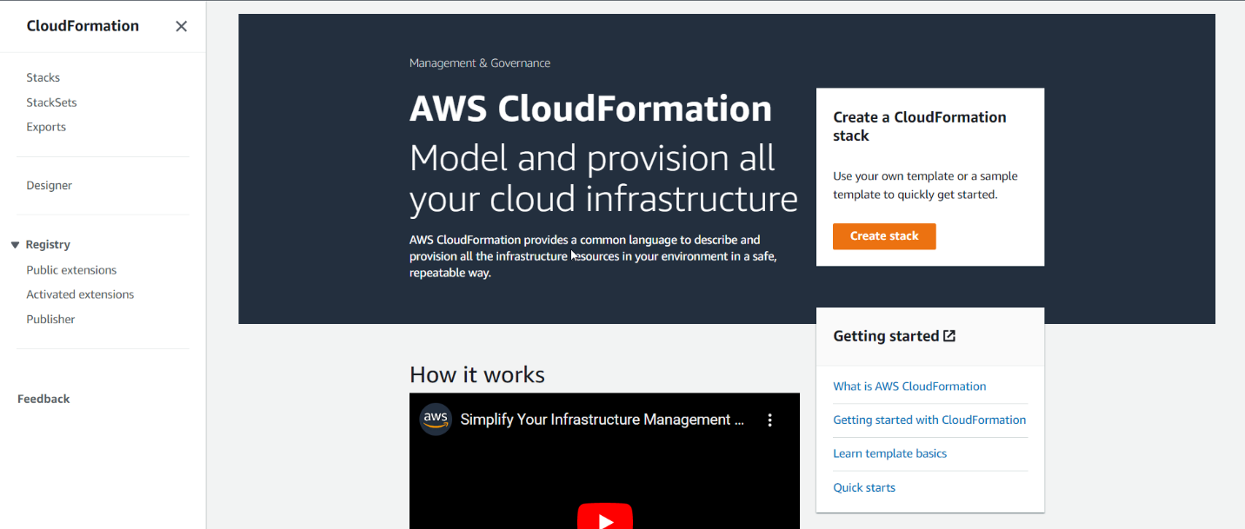

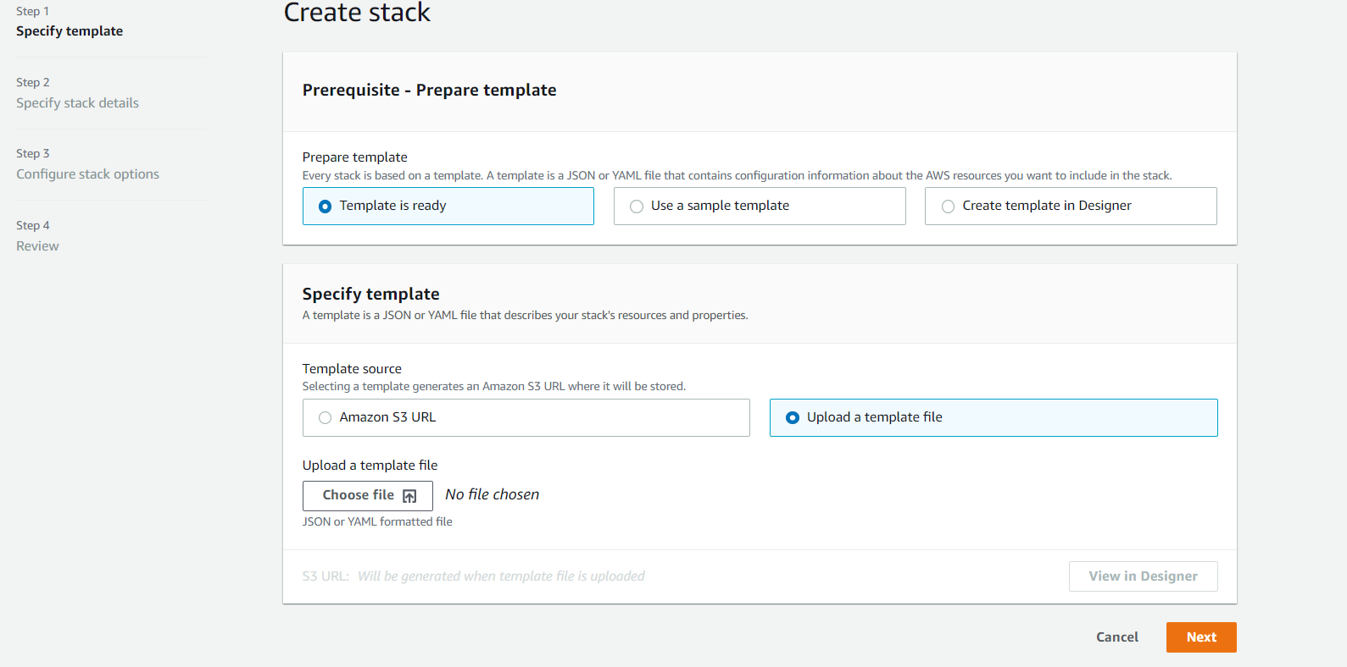

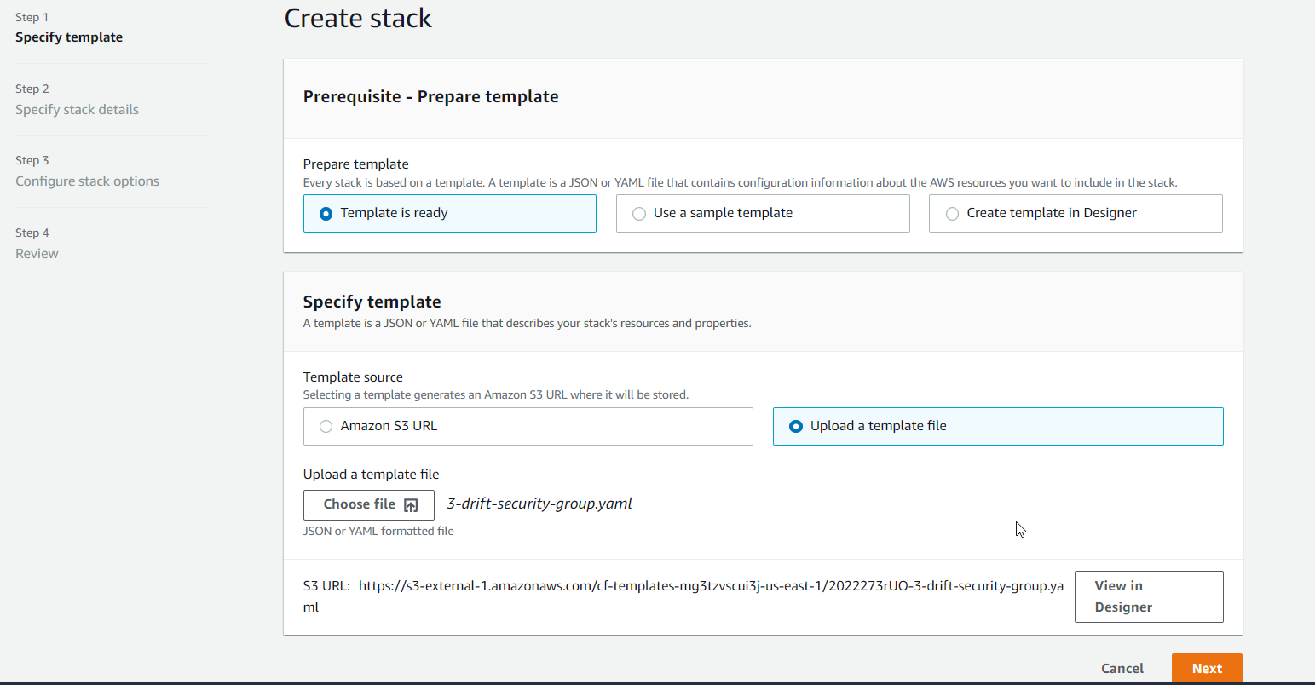

**Click view in designer**

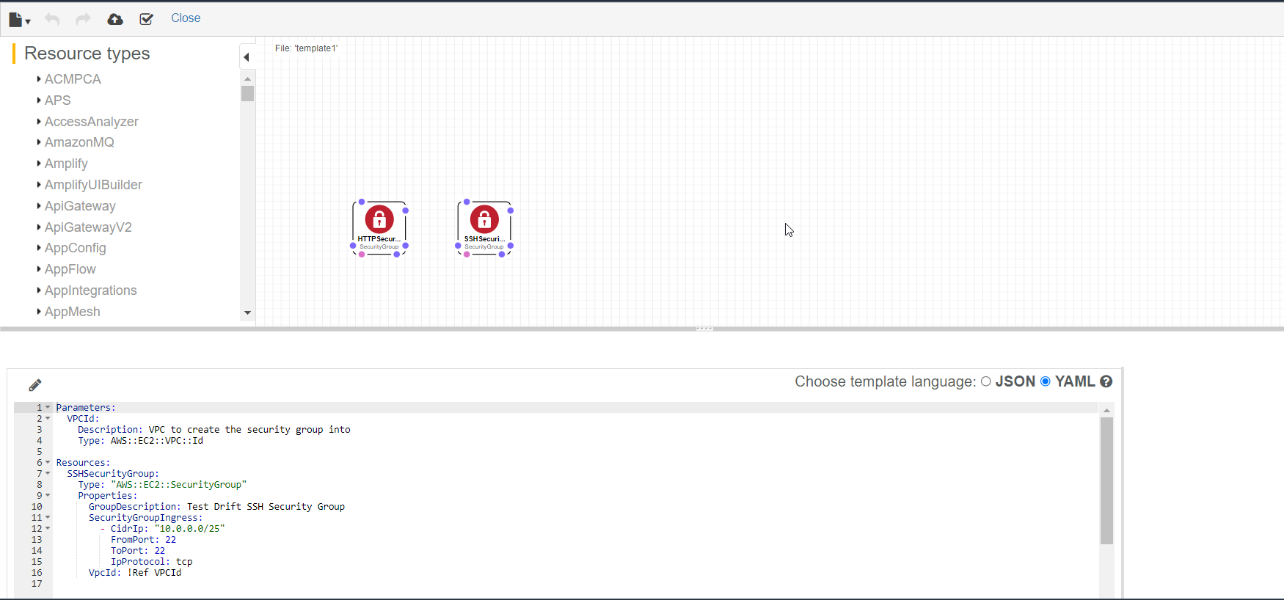

**Click on cloud upload button**

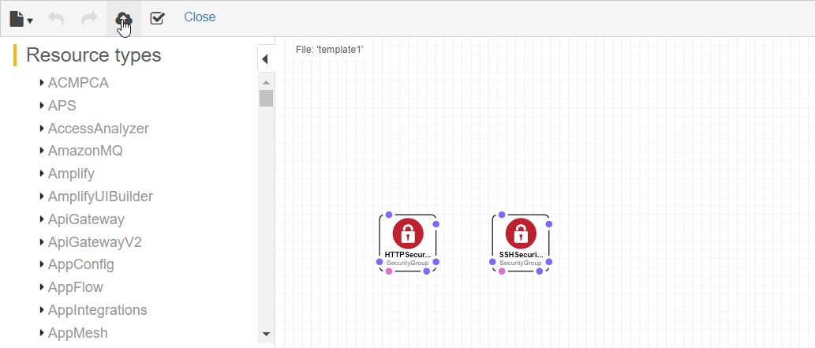

**Click Next**

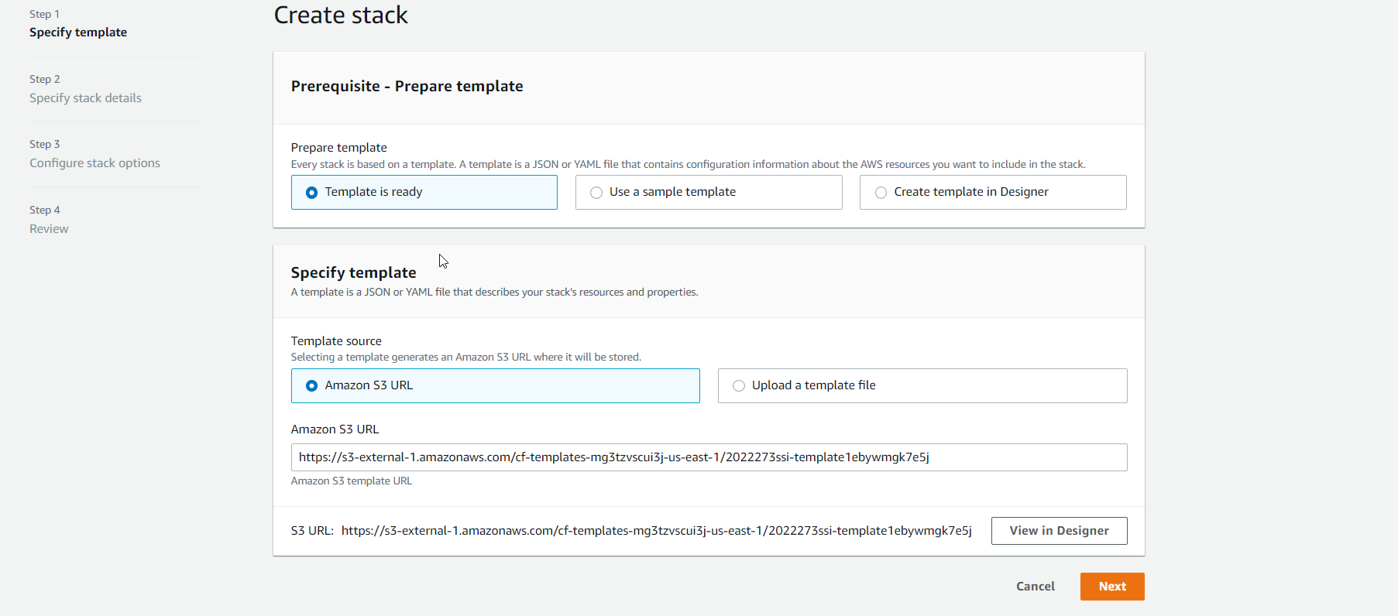

**Choose VPC and name stack.**

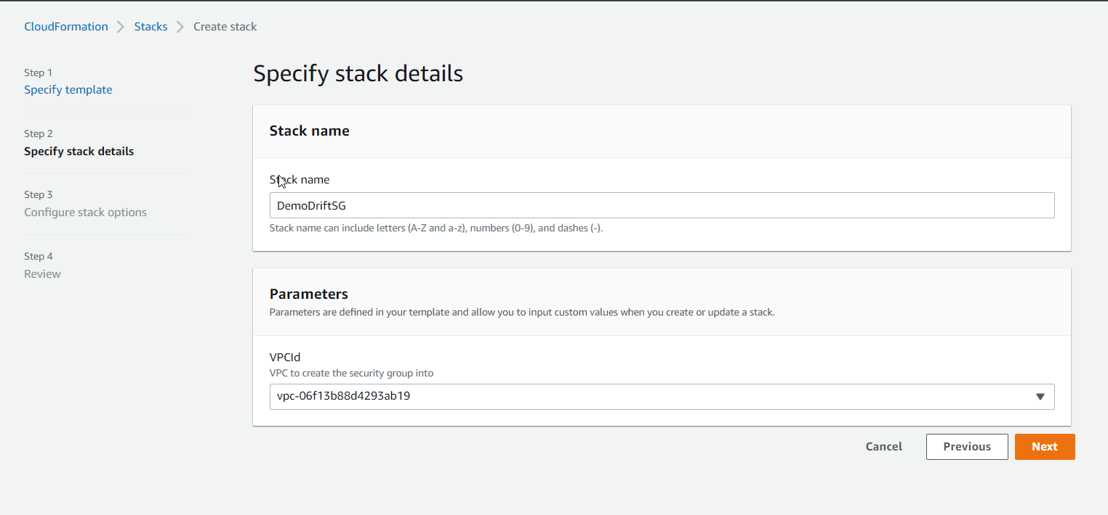

**Default Configure stack options**

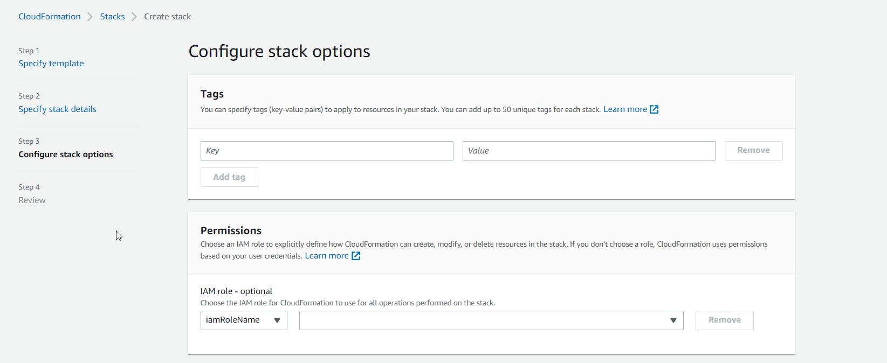

**Click create stack**

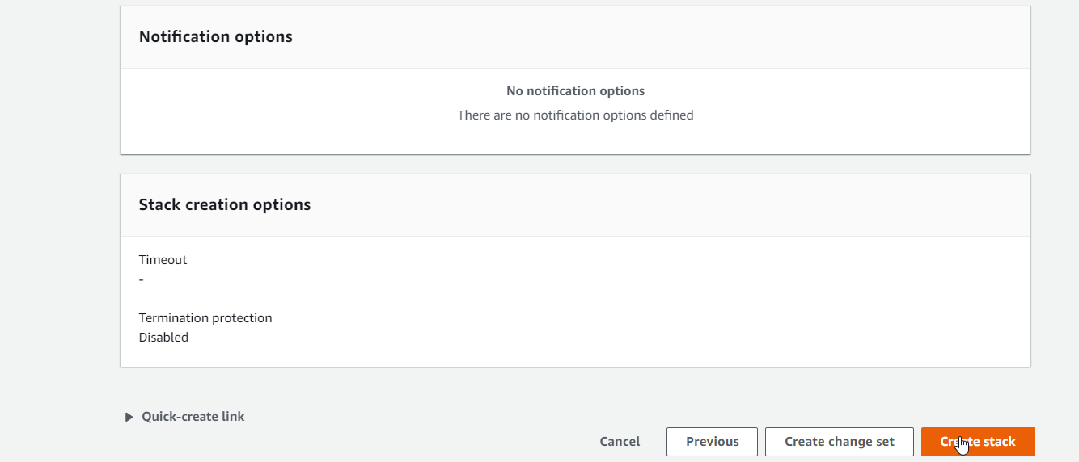

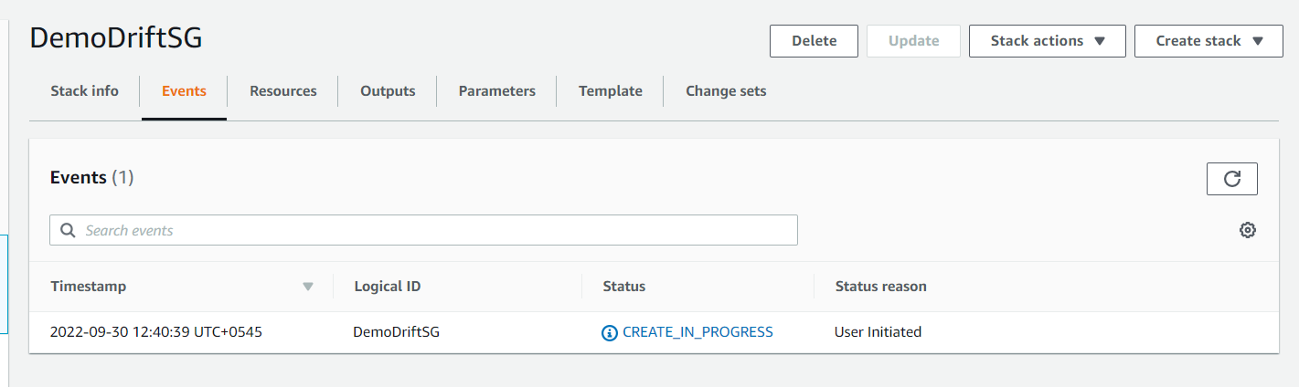

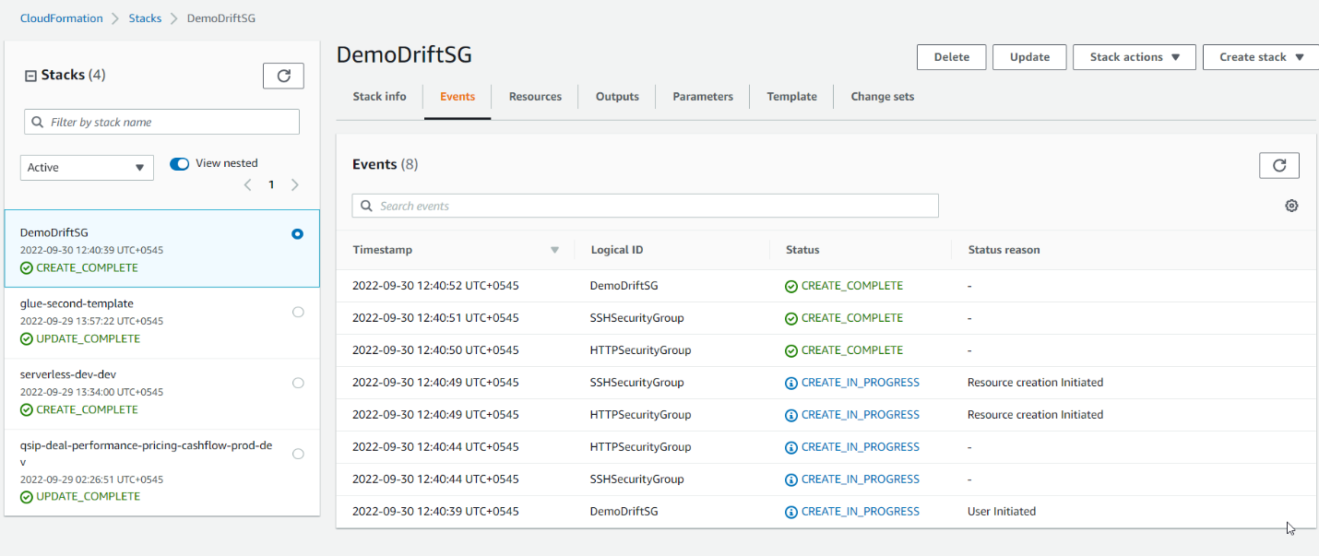

**Click two different security group link**

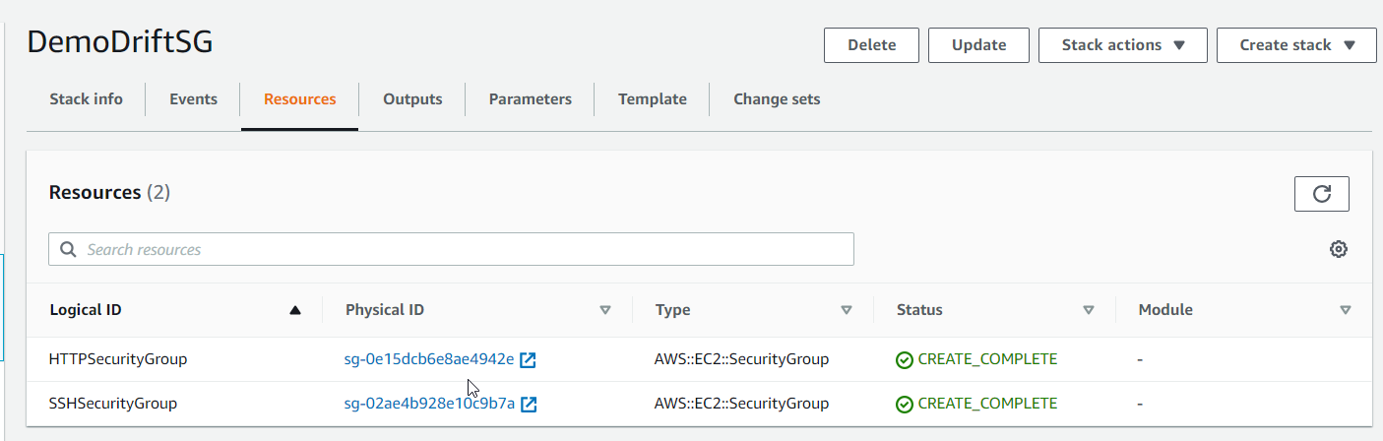

**Add inboud in httpssecuritygroup**

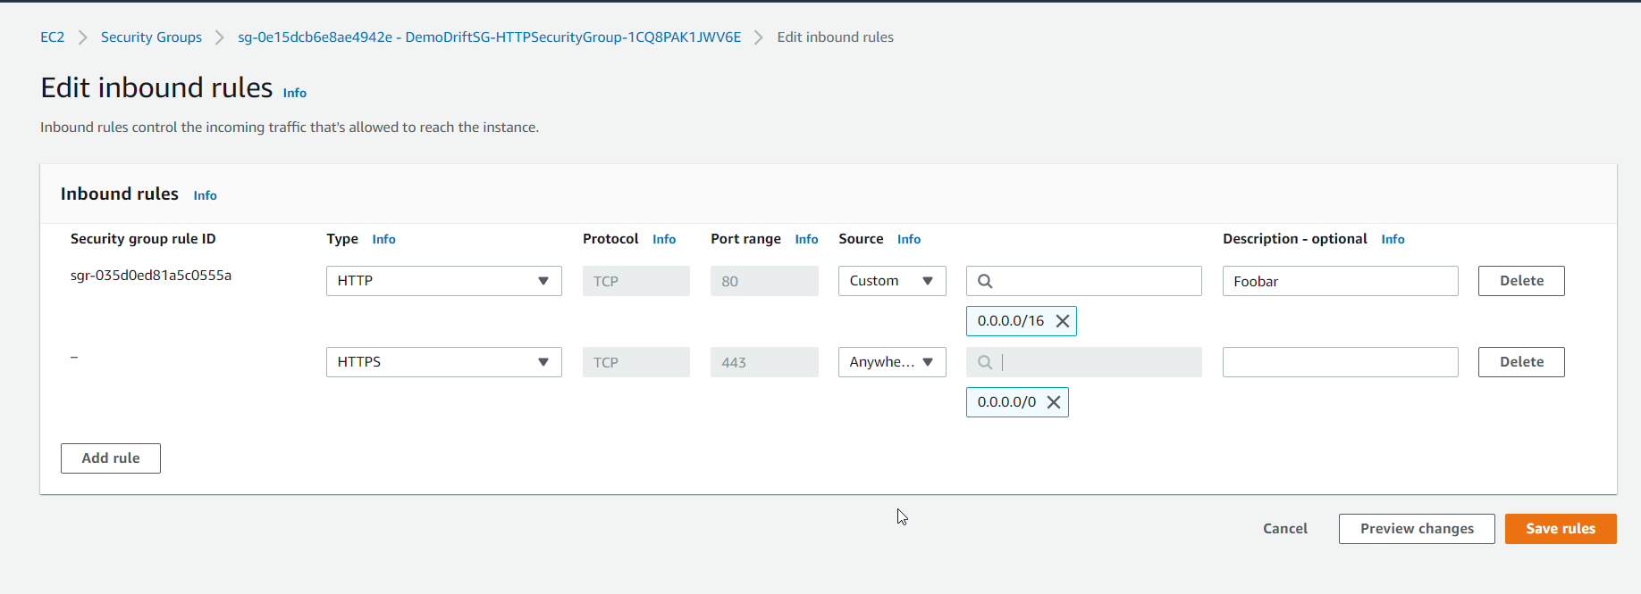

**Go to inbound ssh security group**

**Delete inbound rule**

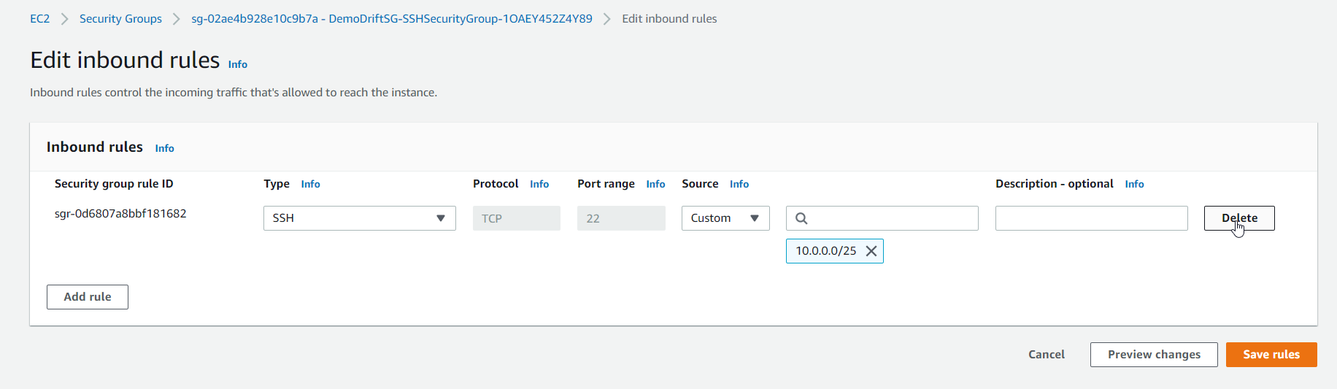

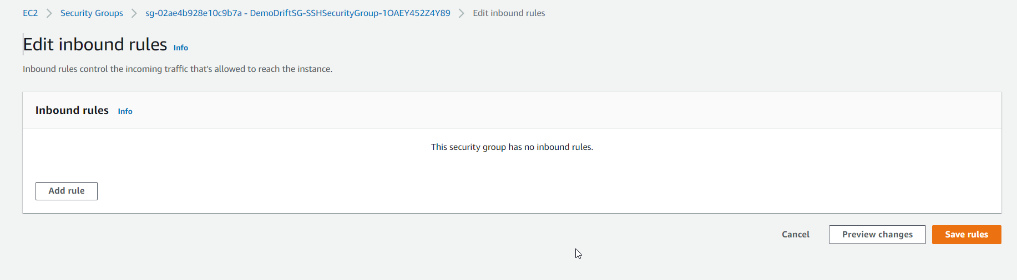

**Go to cloud formation**

**Click stack action**

**Click DetectDrift.**

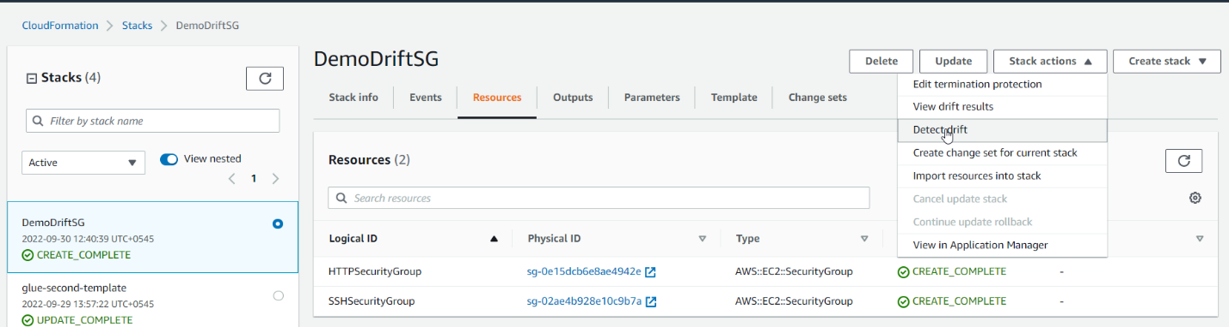

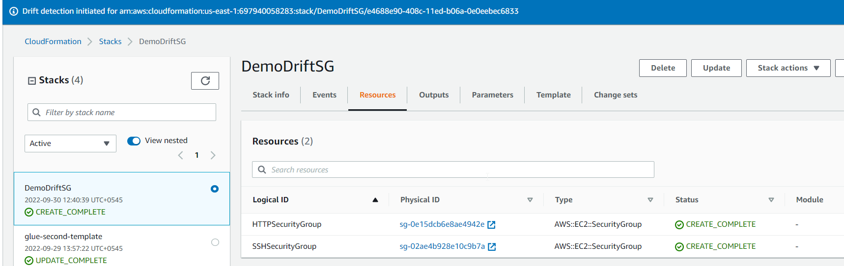

**Click view results**

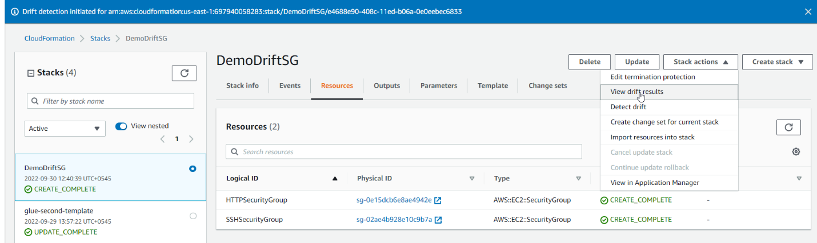

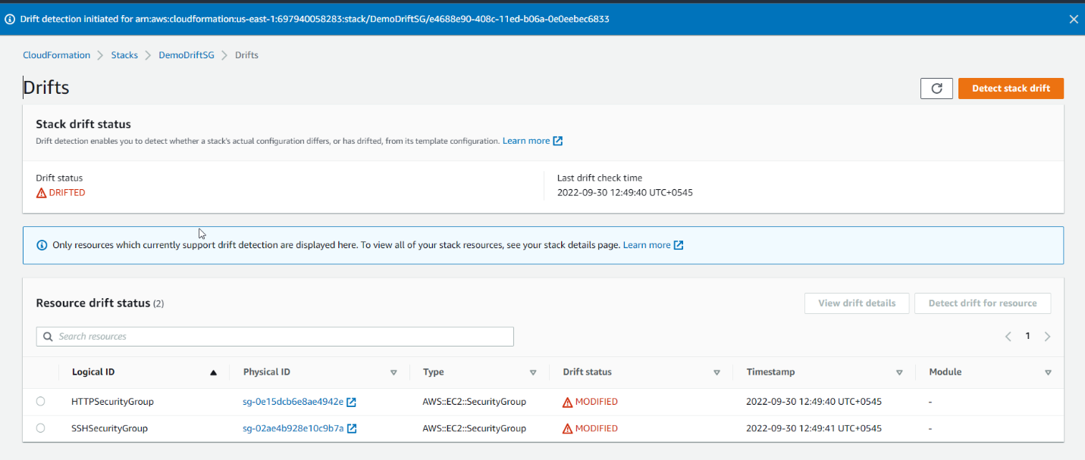

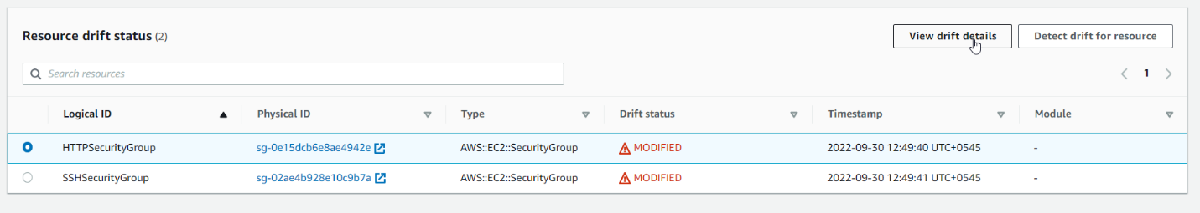

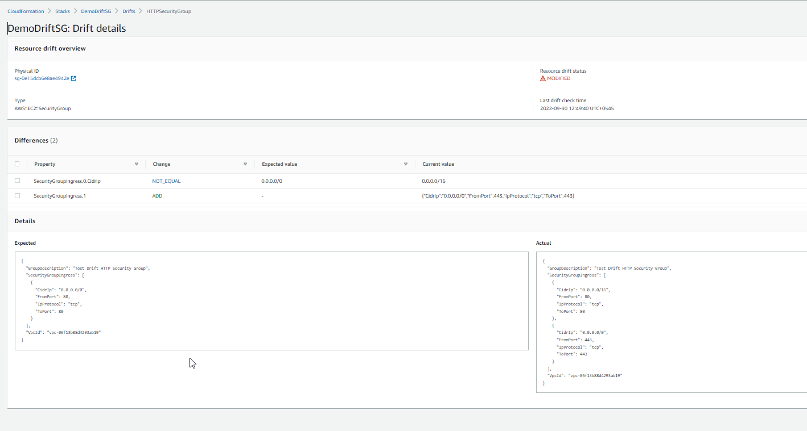

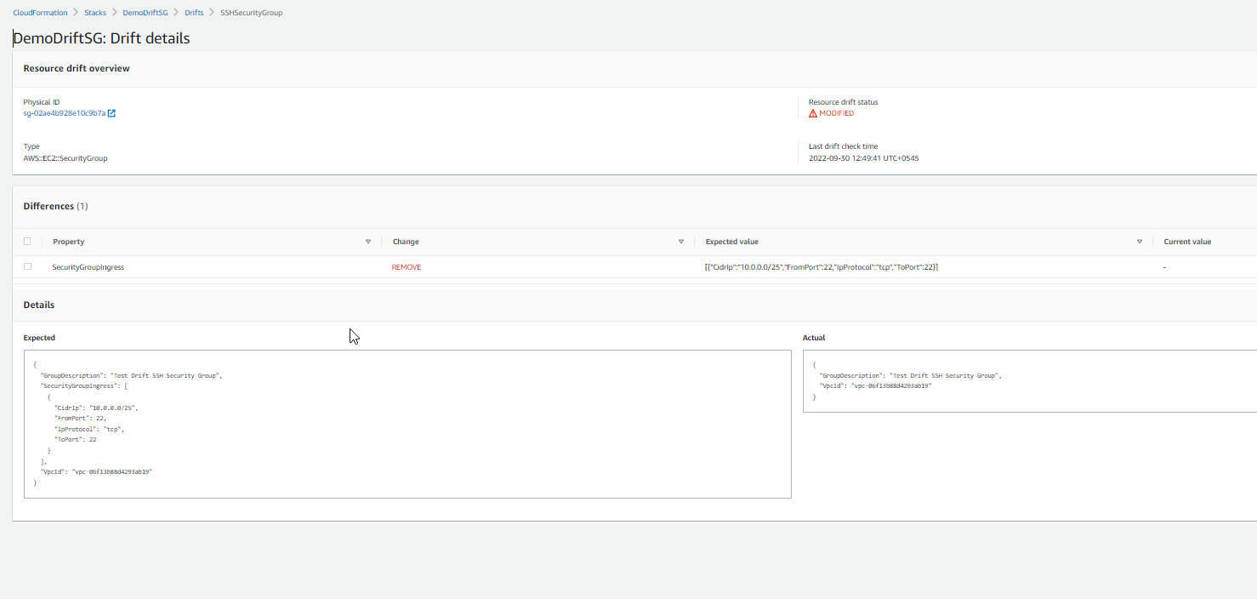

**You can see drift on cloud formation**

